Submitted By: Aadya Shukla
Roll No: 202401100200001
Sem/Sec- V-A
Subject- Software Engineering Lab

Activity Diagram: University Erp Management System

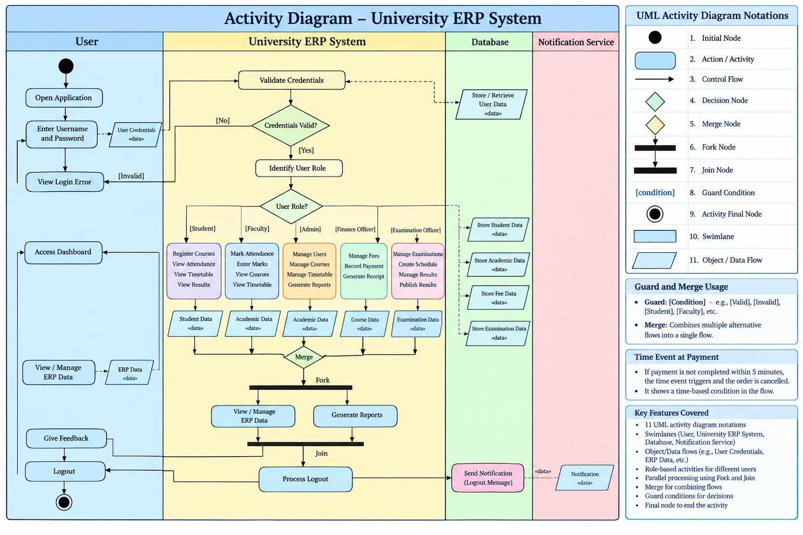

Core Workflow Breakdown
- User Authentication: User enters login details. System validates them against the database.
- Error Handling: Invalid credentials trigger a login error loop.
- Role Identification: Valid credentials unlock specific dashboard permissions.
- Student Path: Handles course registration, attendance, timetables, and results.
- Faculty Path: Manages marking attendance, entering marks, and viewing schedules.
- Admin Path: Controls user profiles, course catalogues, timetables, and reporting.
- Finance Path: Processes student fees, payments, and receipts.
- Exam Path: Coordinates exam schedules, grading, and publishing results.
- Database Storage: Every path syncs data directly to the central database.
- Concurrent Actions: A fork node enables simultaneous report generation and data viewing.
- Session Termination: System rejoins tasks to process logout and trigger notifications.
Key UML Notations Used
- Swimlanes: Divided columns grouping actions by responsible entity.
- Action Nodes: Rounded rectangles representing operational steps.
- Decision Nodes: Diamonds routing paths based on guard conditions.
- Merge Nodes: Diamonds combining multiple alternative flows.
- Fork & Join: Thick horizontal bars managing parallel processing.
- Data Flow: Rectangles showing physical objects or data inputs/outputs.

